**Join us online or in person and earn your Renters’ Readiness Certificate for FREE!**

**A Renters’ Readiness Certificate boosts your rental application and provides you with powerful tools to become a strong renter. These classes are FREE and open to all housing shoppers, service providers, landlords, and community members.**

**For more information email the Housing Stabilization Team:**

[HSP@associatedministries.org](mailto:HSP@associatedministries.org) **or call HSC at 253.426.1503**

Renters’ Readiness Classes

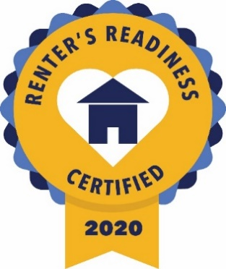

**For more information, email the Housing Stabilization Team:**

[HSP@associatedministries.org](mailto:HSP@associatedministries.org) **or call HSC at 253.426.1503**

**Register Early and Get Reminders, or Register and Enter at Time of Class**

In-person classes held at:

|  |  |
| --- | --- |
| Tacoma Housing Authority Building(4/7 & 4/14)  901 S “L” St., Tacoma 98405 | Associated Ministries(4/21 & 4/28)  901 S 11th St, Tacoma 98405 |

**REGISTER NOW!** <https://forms.gle/fEz8CjSfzS3ZvKRe6>

**2023**

**CLASS 1 – ACCESSING COMMUNITY RESOURCES**

**Friday (April 07, 2023) 11:00 AM - 1:00 PM**

Maintain your rental housing by utilizing community resources that offset costs in other areas of your life. Also hear expert tips on how to search for housing, understand your lease, and become a knowledgeable renter. Instructed by Associated Ministries.

**CLASS 2 – FINANCIAL CAPABILITY**

**Friday (April 14, 2023) 11:00 AM - 1:00 PM**

Learn how to set a budget and improve your credit score. Participants who successfully complete this session gain access to ongoing programs with Sound Outreach to continue their progress toward financial stability. Instructed by Sound Outreach.

**CLASS 3 – LANDLORD/TENANT RIGHTS & RESPONSIBILITIES**

**Friday (April 21, 2023) 11:00 AM – 1:30 PM**

Understand your rights and responsibilities under the landlord/tenant laws in Tacoma and Washington State. Instructed by Mark Melsness from Spinnaker Property Management.

**CLASS 4 – FAIR HOUSING BASICS: UNDERSTANDING YOUR RIGHTS**

**Friday (April 28, 2023) 11:00 AM – 1:00 PM**

Understanding Washington State housing laws. Instructed by Fair Housing Center of Washington.

*(Please note: participants must attend all three sessions to receive the certification.*

*Classes do not need to be taken in order. Classes will be both in-person and online.)*