3

**Join us online and earn your Renters’ Readiness Certificate for FREE!**

**A Renters’ Readiness Certificate boosts your rental application and provides you with powerful tools to become a strong renter. These classes are FREE and open to all housing shoppers, service providers, landlords, and community members.**

**For more information email the Housing Stabilization Team:**

[HSP@associatedministries.org](mailto:HSP@associatedministries.org) **or call HSC at 253.426.1503**

Renters’ Readiness Classes

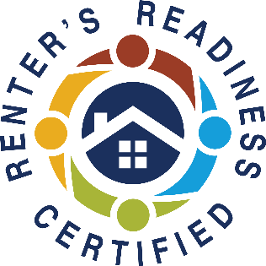

**Register Early and Get Reminders, or Register and Enter at Time of Class**

All classes are online ONLY

**REGISTER NOW!** <https://forms.gle/fEz8CjSfzS3ZvKRe6>

Join zoom meeting <https://us06web.zoom.us/j/86997333549?pwd=RkcyUEthaFpObDF5bEF1dXpWQURpdz09>

Meeting ID: 869 9733 3549

Passcode: 283017

**CLASS 1 – LANDLORD/TENANT RIGHTS & RESPONSIBILITIES**

**Tuesday (November 21st, 2023) 11:00 AM – 1:30 PM**

Understand your rights and responsibilities under the landlord/tenant laws in Tacoma and Washington State. Instructed by Mark Melsness from Spinnaker Property Management.

**CLASS 2 – ACCESSING COMMUNITY RESOURCES/Financial Capability**

**Wednesday (November 22nd, 2023) 11:00 AM - 1:00 PM**

Maintain your rental housing by utilizing community resources that offset costs in other areas of your life. Also hear expert tips on how to search for housing, understand your lease, and become a knowledgeable renter. Instructed by Associated Ministries.

*(Please note: participants must attend all three sessions to receive the certification.*

*Classes do not need to be taken in order. Classes will be both in-person and online.)*