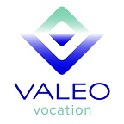  A non-profit staffing agency and social enterprise  ARE YOU UNEMPLOYED?  We can help!  At Valeo Vocation, we do staffing differently.  Our staffing services include:  - General labor and light industrial employment opportunities  - Case management to navigate resource systems  - Financial assistance to remove barriers and enhance success in the workplace | NEW CLIENT ORIENTATIONS  held every Tuesday from 1PM to 3PM at  1224 Tacoma Ave S  Tacoma WA  Please bring Photo ID and authorization to work in the United States  QUESTIONS?  Contact  Mitch Austin  253-732-2966  mitch@  valeovocation.org  Valeo vocation  1224 Tacoma Avenue S  Tacoma, WA  98405  www.valeovocation.org

