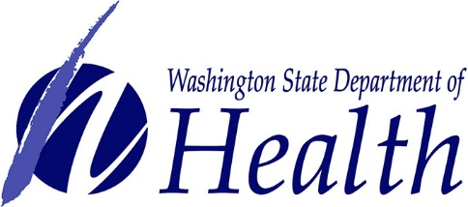
Naloxone Request Form
The Washington State Department of Health has a new Overdose Education & Naloxone Distribution Program that may be able to provide training, technical assistance, and naloxone in order to support an overdose prevention program at your organization.
We are interested in working with organizations in Washington State that are able to get naloxone into the hands of the people most likely to witness and respond to an overdose- people who use drugs and their friends and family. Some organization examples are jails and prisons (for persons about to be released into their community), drug treatment programs, transitional/abstinence-based housing, programs serving the homeless and marginally housed, and other agencies that work directly with persons who use drugs.
If you would like to request naloxone kits and other assistance, please fill out this form and the attached “SHIPPING ADDRESS VERIFICATION FORM”, and return it to sean.hemmerle@doh.wa.gov . Please note that this form is not an order form. If you have any questions, please email Sean, or call (360) 236-3456.

Organization Name:

Please indicate what type of organization your agency most closely identifies as (you may check multiple if your organization provides multiple services):

☐ Jail
☐ Prison
☐ Re-entry program
☐ Diversion program (e.g., drug court, LEAD)
☐ Drug treatment program (not including opioid treatment program)
☐ Opioid treatment program
☐ Hospital emergency department
☐ Supportive housing program
☐ Abstinence-based housing program
☐ Drop-in program / day shelter for people living homeless
☐ Night shelter
☐ PATH Program
☐ Healthcare for the Homeless
☐ Health clinic (e.g., federally qualified health center, rural health center, community health clinic)
☐ Syringe service program (Note that we are not providing naloxone to SSPs that currently get naloxone from UW ADAI)
☐ HIV service organization

☐ Other (please describe):
Name and title of the person(s) who will be responsible for ordering, receiving, and distributing naloxone for your organization, including their direct contact information:

Physical address where you would like the naloxone delivered to (please include any restrictions or issues you think might interfere with delivery (e.g., limited hours of operation, remote access) :

Does your organization require training around overdose awareness, prevention, and response for your staff or participants?

Your projected need for naloxone in the coming year (10 kits, 100 kits, etc.). Keep in mind that naloxone can take up physical space, needs to be stored at room temperature, and does expire roughly 12 to 18 months after delivery, so plan accordingly!

Please describe your organization’s ability to report to us the number of naloxone kits you distribute, and if you’re able to find out when a kit has been used to reverse an overdose (NOTE: Reporting details are still being finalized, and we would like to make this program as accessible as possible, so please do not take this ask as a deterrent- your input here will help us create a solid foundation for this program’s future!):

In order for your organization to receive and distribute naloxone to participants, you will need to complete and submit to McKesson the SHIPPING ADDRESS VERIFICATION form in the Adobe link below before we are able to place your order. If you have questions about how this relates to your organization’s needs, please visit http://stopoverdose.org/section/start-a-naloxone-program/ for more information, or contact us with questions or concerns.
We will respond to requests within 5 business days with questions or with a decision. We will prioritize requests based on available resources and ability for programs to reach the people at greatest risk for experiencing or witnessing overdose.
We hope that we’ll be able to help you to create (or continue) a program that addresses the needs of your organization and community, and we thank you for helping us to get naloxone into the hands of those in need!

