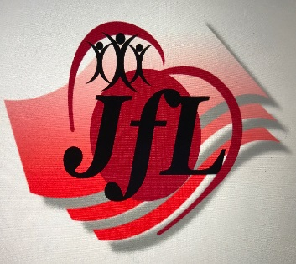

A ministry of:

#### **Bridges of Love NW**

Jobs for Life- Engaging people to actively live

out their potential!

What is Jobs for Life?

**Jobs for Life** (JfL) is a 16 week biblically based job readiness program. During your 16 weeks you’ll w learn:

* Identify your ideal career through The Career

Assessment

* Knowledge on how to create a professional

Resume

* What are your community resources?

* How to write a Vocational Plan (from going back to school, working a temporary job, etc.)
* Be confident and comfortable with

Interviewing for potential career

* Be able to share the best of yourself in 60 seconds or less and why they should hire you.
* One on one Mentoring
* Learn what God says about you, your life

and work

* Recognizing and overcoming Roadblocks
* Gain a network of people who want to see

you reach your God given potential to provide for you and your family… and so much more!

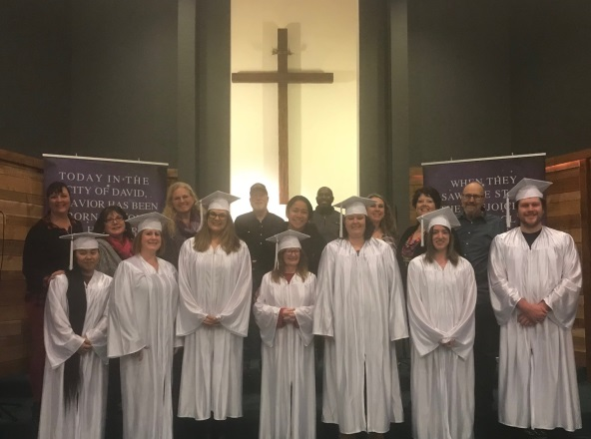

Commonly Asked Questions:

The program commitment is for 15 weeks. We meet one evening a week for two hours. We provide dinner ½ hour before class and childcare during the program. You will receive a $15 gas card each week, **whenyou meet the weekly requirements of active participation in classroom activities,** turning in your “Required Task” and job searches.



**Have more questions?**

Then call Sarah or Sherry: (253) 531-2366

Monday through Thursday 9:00am to 2:00pm

or email Sherry at:

Sherry@Bridgesoflovenw.org

**What does the program cost to attend?**

Nothing! Thanks to the generous support of churches and community partners.

**What are the requirements to attend?**

You must be able to work, 18 years or older and not receiving state disability.

Fill out the student application at: <http://bridgesoflovenw.org/ministry-model/get-involved-2/jobs-for-life-application.> Attend an orientation. Show up to class!

**Do I have to have a high school diploma or GED?** No

**Do you work with people with a criminal past?** Yes, on an individual basis.

**Is there child care?** Yes! At no cost to you.

**What about Transportation?** It is up to you to get yourself there. We provide gas cards every week to those who complete their class work, turn in all of required tasks and job searches before class starts and active participation in class discussions.

**Where are the classes held at?**

Our classes are held at a local church that donates the space.

**Do I have to believe in God to become a student?**

No! However, we are a biblically based program, using materials from the Bible in our teachings.

**Interesting in becoming a student?**

Apply online at: <http://bridgesoflovenw.org/ministry-model/get-involved-2/jobs-for-life-application.http>

Deadline for our February 2019 program is January 17th and space is limited to 12 students.