Hosted by Associated Ministries
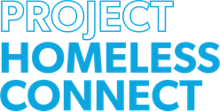
FRIDAY, OCTOBER 11, 11am - 3pm

Tacoma North Stake of
The Church of Jesus Christ of Latter-Day Saints
1102 S. Pearl St, Tacoma WA 98465

Project Homeless Connect is a community event to serve those experiencing homelessness in Pierce County. This event offers services and respect to people living in their cars or on the streets. It includes Community Resources, haircuts, Veterans Services, showers, lunch, refreshments, housing and career assistance, medical and dental care and vaccines.

Would you like to help?

Associated Ministries has asked for:

New or gently used adult warm coats
New socks (men’s or women’s sizes)
New (packaged) Men’s and Women’s underwear

Give any donations to Kelly Blucher at Goodwill (kellyb@goodwillwa.org)

