99 Stockings
a.k.a. 140 Stockings plus 60 Holiday Gift Bags!

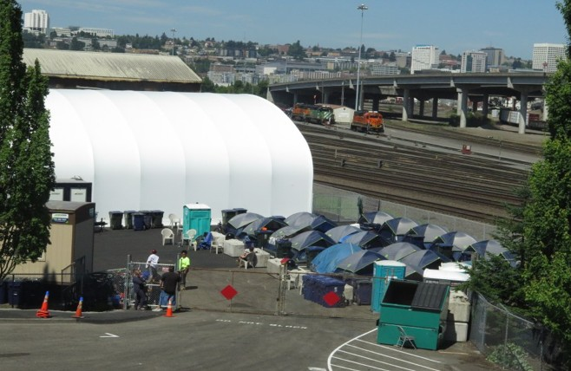
Merry Makers
In 2018, New Connections, and Shelter 253 (a workgroup of the Pierce County Coalition to End Homelessness), set out to create a little holiday cheer for the 99 campers at Tacoma’s Stability Site. Soon the amazing students at Stadium High joined us to make stockings for 41 youth at the Beacon Young Adult Shelter. Then the Hilltop Madrinas offered to make holiday bags for the 60 guest at the Guadalupe Christmas meal. Thanks to all who contributed gift cards & other items, and to those who assembled stockings and bags. This year, the PNW Insurance Group is helping us collect items for the stockings too. Please consider joining the 2019 Merry Makers!
The Stability Site on Puyallup Ave. Photo by Steve
Dunkelberger used with permission (thank you Steve!).

The Plan for 2019:
1. Gather all items by Friday, December 13th
2. Fill the stockings & bags on: date to be decided
3. Deliver to all locations on, or before, December 24th

We are asking for donations of the following items so that every stocking will contain these things. Items that are listed as “200 needed” will be included in the stockings and also in the Guadalupe gift bags.
We are grateful to the elected officials, government employees, non-profit agencies and individuals who offer shelter, provide for basic needs, and address the systemic issues and individual challenges that contribute to homelessness.
Want to join this effort?
Tacoma/Pierce County Coalition to End Homelessness: www.pchomeless.org

Item | number  needed |  | Item  (small/travel size) | number needed
holiday stocking to fill | 140 |  | toothpaste | 200
holiday gift bag to fill | 60 |  | soap | 200
$10 gift card (coffee shop) | 140 |  | tissues | 200
insulated travel mug | 140 |  | disposable razor | 200
hand warmer (disposable) | 140 |  | hand lotion | 200
stocking hat | 140 |  | shampoo | 200
reusable shopping tote | 140 |  | conditioner | 200
gloves | 200 |  | Lip balm | 200
Warm neck scarf | 200 |  | Band-Aid pack | 200
reusable shopping tote | 140 |  | hand sanitizer | 200
washcloth | 200 |  | Treats
small ornament | 200 |  | orange | 200
socks | 200 |  | candy cane | 200
comb | 200 |  | chocolate Santa | 200
toothbrush | 200 |  | snack bar | 200
Deck of playing cards | 200 |  | other sweets | any

Financial contributions for purchase of supplies can be made to New Connections, a 501c3 non-profit agency in Tacoma. There are no administrative costs for this project; 100% of contributions designated “for holiday stockings” will be used to fill the stockings. Any excess (non-perishable) supplies will be saved for 2020; “excess” treats will be added to the stockings and bags as we fill them.

Contact Theresa Power-Drutis (253.534.5402) or Laura Scott (lrkscott9@gmail.com) to arrange for drop off of donations. We are happy to receive single items. Swag with logos is fine too; each stocking & gift bag will be unique. If you have ideas for other items to add to the stockings, send those along as well. Every little bit helps!

New Connections 613 S. 15th Street, Tacoma, WA 98405 www.nctacoma.org

