January
2021
New Hope Mobile Resources Response Team  This is the current schedule for January 2021. . Dates and locations may be updated.  Changes will be sent out immediately.  Questions? Email Paula Anderson andepaa12@msn.com  Typical hours of operation 10:00 am- 3:00 | 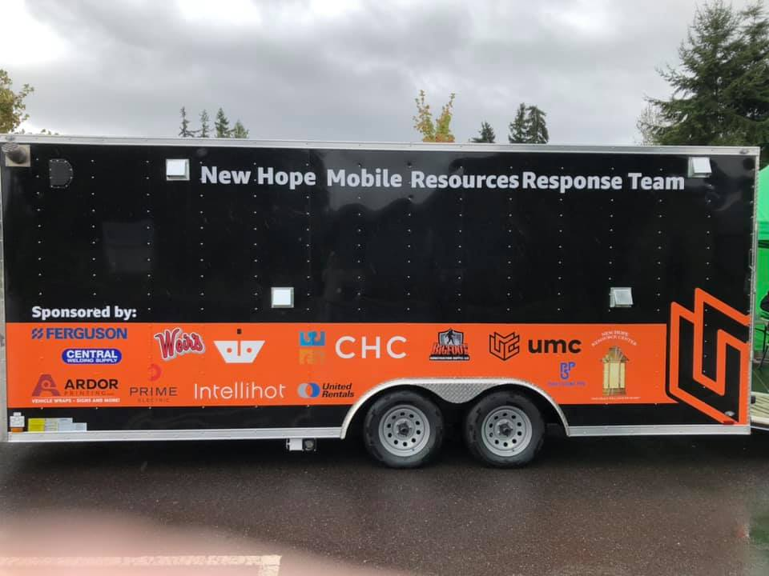
Sunday | Monday | Tuesday | Wednesday | Thursday | Friday | Saturday
 |  |  |  |  | 1 | 2
3 | 4 | 5 | 6 | 7 | 8 | 9
 | Spanaway Methodist Church  135 163rd St. S  Spanaway  CANCELLED | Church for all Nations-  111 112th St. E Tacoma  CANCELLED |  |  | Rainer View Christian Church  7420 224th St. E  Graham  CANCELLED
10 | 11 | 12 | 13 | 14 | 15 | 16
South Hill Baptist
7914 112th St E
Puyallup
TENTATIVE
17 | 18 | 19 | 20 | 21 | 22 | 23
 | Spanaway Methodist Church  135 163rd St. S  Spanaway | Church for all Nations-  111 112th St. E Tacoma |  |  | Rainer View Christian Church  7420 224th St. E  Graham
24 | 25 | 26 | 27 | 28 | 29 | 30
South Hill Baptist
7914 112th St E
Puyallup
31

