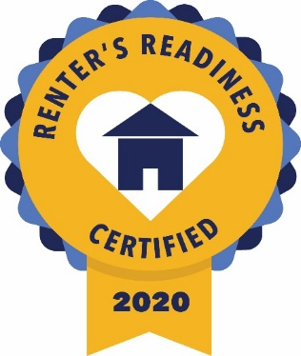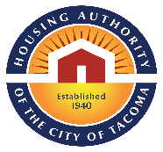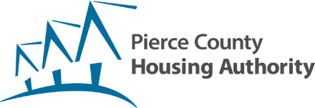

**Join us online and earn a Renters’ Readiness Certificate for FREE!**

**A Renters’ Readiness Certificate boosts your rental application and provides you with powerful tools to become a strong renter. These classes are FREE and open to all housing shoppers, service providers, landlords, and community members.**

**For more information visit the Landlord Liaison Program website at:**

[**www.landlordliaisonprogram.com**](http://www.landlordliaisonprogram.com) **or call LLP at 253.426.1503**

**Participants must attend all three classes to get the certificate**

**Class 1 – Friday, July 9, 2021 11:00 AM - 1:00 PM**

**ACCESSING COMMUNITY RESOURCES** – Maintain your rental housing by utilizing community resources that offset costs in other areas of your life. Also hear expert tips on how to search for housing, understand your lease, and become a knowledgeable renter. Instructed by Sandra Iverson from Vadis Resources.

**Class 2 – Friday, July 16, 2021 11:00 AM - 12:30 PM**

**FINANCIAL CAPABILITY** – Learn how to set a budget and improve your credit score. Participants who successfully complete this session gain access to ongoing programs with Sound Outreach to continue their progress towards financial stability. Instructed by Kenan Hadzic from Sound Outreach.

**Class 3 – Friday, July 23, 2021 11:00 AM – 1:30 PM**

**LANDLORD/TENANT RIGHTS & RESPONSIBILITIES** – Understand your rights and responsibilities under the landlord/tenant laws in Tacoma and Washington State. Instructed by Mark Melsness from Spinnaker Property Management.

REGISTER NOW! <https://forms.gle/fEz8CjSfzS3ZvKRe6>

**Register Early and Get Reminders, OR Register and Enter Class at Time of Class**

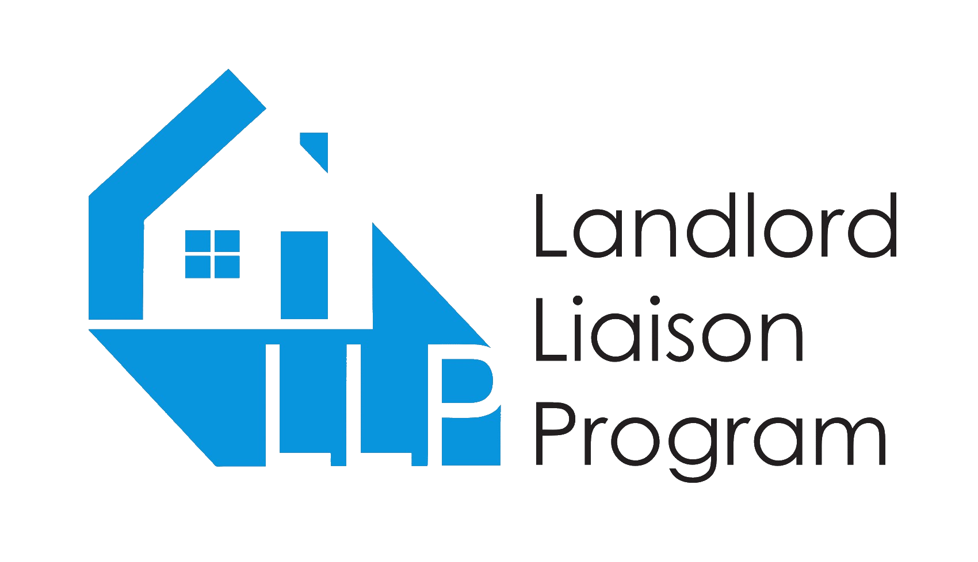

Renters’ Readiness Classes