3PM Cold Weather Update
December 30th, 2021, 3PM
Pierce County Human Services

Meeting Location: https://piercecountywa.zoom.us/j/95523208556
Meeting ID: 955 2320 8556
Dial by your location
+1 253 215 8782 US (Tacoma)
888 788 0099 US Toll-free
Meeting ID: 955 2320 8556
Find your local number: https://piercecountywa.zoom.us/u/adnQvG4cbE
Staff – John Barbee, Gerrit Nyland, Delmar Algee, Annie Marie Edwards, Sarah Appling, Bryan Barmore
Time | Agenda
3pm | Current Status – Cold Weather Update
TPCHD Update
Emergency Shelters/Shelter Expansion:
Agencies w/ Hotel Vouchers:
Warming Centers:
Churches Serving as Temp Shelter:
Information Hubs:
Inclement Weather Shelters:
Safe Parking Sites:
Outreach:
Distribution Centers
Open Discussion:
Recap of Action Steps:
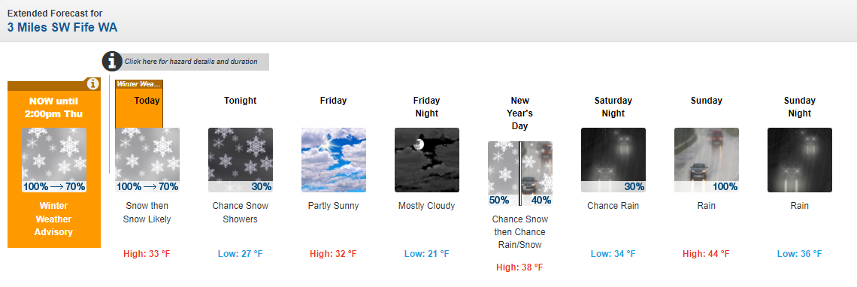
https://forecast.weather.gov/MapClick.php?lon=-122.41104125976562&lat=47.20913220827748#.YcoCAGDMKUk

Special Weather Statement

Winter Weather Advisory
URGENT - WINTER WEATHER MESSAGE
National Weather Service Seattle WA
348 AM PST Thu Dec 30 2021

WAZ001-504-506-507-509>512-514-556-558-559-302200-
/O.EXT.KSEW.WW.Y.0041.000000T0000Z-211230T2200Z/
San Juan County-Southwest Interior-Western Skagit County-
Everett and Vicinity-Tacoma Area-Admiralty Inlet Area-
Hood Canal Area-Lower Chehalis Valley Area-
Eastern Strait of Juan de Fuca-Bellevue and Vicinity-
Seattle and Vicinity-Bremerton and Vicinity-
including Friday Harbor, Eastsound, Lacey, Olympia, Tumwater,
Yelm, Grand Mound, Rochester, Centralia, Toledo, Burlington,
Mount Vernon, Sedro-Woolley, La Conner, Conway, Everett,
Lynnwood, Marysville, Stanwood, Tacoma, Fife, DuPont, Puyallup,
Port Townsend, Oak Harbor, Coupeville, Langley, Shelton, Seabeck,
Belfair, Brinnon, Montesano, Elma, McCleary, Sequim,
Port Angeles, Bellevue, Bothell, Kenmore, Mill Creek, Clearview,
Kirkland, Newcastle, Redmond, Sammamish, Issaquah, Seattle,
White Center, Tukwila, Renton, Burien, Des Moines, Kent,
Federal Way, Bremerton, Poulsbo, and Indianola
348 AM PST Thu Dec 30 2021

...WINTER WEATHER ADVISORY NOW IN EFFECT UNTIL 2 PM PST THIS
AFTERNOON...

* WHAT...Snow continued. Additional snow accumulations of up to
4 inches.

* WHERE...Portions of northwest and west central Washington.

* WHEN...Until 2 PM PST this afternoon.

* IMPACTS...Plan on slippery road conditions.

PRECAUTIONARY/PREPAREDNESS ACTIONS...

Slow down and use caution while traveling.

For the latest road conditions in Washington state, call 5 1 1.

&&

$$

WWA Summary by Location for 47.19N 122.45W with WAZ509/WAC053/WAZ654 emphasis Special Weather Statement

