Why We Don’t Know How the Pandemic Affected U.S. Homelessness
  - The latest federal point-in-time count on homelessness reveals how the pandemic disrupted data-gathering on how many people were living in shelters and on the streets of U.S. cities.
  - https://www.bloomberg.com/news/articles/2022-02-04/what-covid-19-did-to-u-s-homelessness
By Kriston Capps
February 4, 2022, 12:46 PM PST
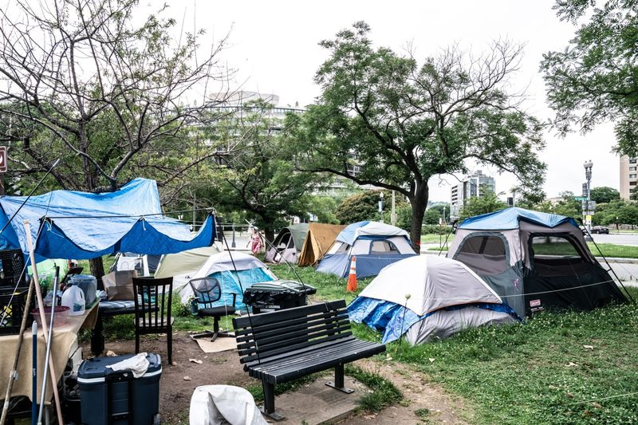
Tents across the street from the Watergate Hotel in Washington, D.C., on June 13, 2021. Photographer: Dee Dwyer/Bloomberg
The number of people in U.S. cities sleeping in shelters shifted dramatically at the height of the pandemic — but maybe not for the reasons government leaders would like.
According to a new count released by the U.S. Department of Housing and Urban Development on Feb. 4, sheltered homelessness across the U.S. fell 8% between 2020 and 2021, a steep drop-off after years of gradual decline. The number of people in families with children staying in shelters registered an even sharper decline, falling by 15%.
Yet the figures, which come from counts of unhoused people from across the country, may tell a clearer story about the severity of the pandemic than about changes in homelessness. HUD’s report measures homelessness at a single point in time, in this case January 2021, when U.S. vaccine distribution was at a very early stage and a winter surge of Covid-19 infections was underway. Congregate settings represented a vector for the spread of infection and shelter capacity was limited.
“It really revealed the fragility of this resource,” says Meghan Henry, senior associate for Abt Associates and research director for HUD’s Annual Homeless Assessment Report. “The capacity of shelters for a lot of places needed to be cut in half, which meant that a lot of people who were staying in shelters needed to find another place to go.”
During the pandemic, Congress delivered billions of dollars in emergency aid that, along with state and local dollars and other resources from HUD, helped people experiencing homelessness find hotel stays and other rapid rehousing options. The federal eviction moratorium and similar state orders limited the number of people forced from their homes for nonpayment of rent. So it would be wrong to say that the apparent dip in sheltered homeless is mistaken or incorrect. But the findings require a big asterisk.
There’s even more uncertainty around unsheltered homelessness, a phenomenon whose visibility in several U.S. cities, especially in California, appeared to spike in 2021. Nearly half of the roughly 400 cities, counties and states that conduct these counts (through programs known as continuums of care or CoCs) asked to postpone or cancel in January 2021 due to fears over the pandemic.
Most of the CoCs that persisted completed full counts of people sleeping outdoors, although many chose not to collect household or demographic data for these people. Looking only at the COCs that conducted counts both in 2021 and 2020, the numbers showed almost no change in unsheltered homelessness: a jog of 0.3%, to almost 50,000 people. But HUD carefully caveats throughout the report that this reporting group is small and unrepresentative. All told, the figures that were delivered account for less than one-quarter of the number of unsheltered homeless people counted in January 2020, before the Covid-19 pandemic. “Almost the entire state of California didn’t do an unsheltered count for 2021,” Henry says.
The federal government doesn’t rely on the point-in-time count exclusively for its understanding of homelessness. Most communities submitted narrative reporting that helps to explain what’s really going on, especially in cities that have seen a stark rise in homeless encampments. And the federal government does other extensive reporting on the forms of support used by local governments to help people in emergencies.
But the pandemic has compounded the problems of using infrequent counts for reporting on homelessness. Those problems existed before the pandemic: North Dakota, for example, registers what appear to be sudden annual spikes and drops in homelessness. These apparent blips are driven by booms and busts in the natural gas industry rush for fracking. With real-time data — a goal for housing advocates — governments would have a clearer picture of the root causes of homelessness and how to respond.
For a full accounting of the effect of the pandemic on homelessness, the public will have to wait another year: The count for 2022 just concluded over the last 10 days of January.

