January 19th, 2025

Parkland Warming Center

Open from 8pm – 8 am

Parkland Community Center/Family Promise Center/Shelter Hub

214 121st S. Parkland, WA

* Warm up

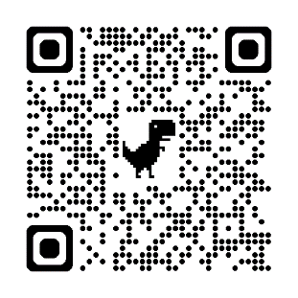

Route 1

* Have a cup of cocoa
* Get a little rest

Busses to the warming center are free tonight.

USE: Route 1 (6TH AVE – PACIFIC AVE)

Shelter Hub (253) 444-4563.

January 19th, 2025

Parkland Warming Center

Open from 8pm – 8 am

Parkland Community Center/Family Promise Center/Shelter Hub

214 121st S. Parkland, WA

* Warm up



Route 1

* Have a cup of cocoa
* Get a little rest

Busses to the warming center are free tonight.

USE: Route 1 (6TH AVE – PACIFIC AVE)

Shelter Hub (253) 444-4563.